***Experiment 11***

**Aim:** Data Cleaning and Preprocessing with Pandas: Use the Pandas library in Python to clean and preprocess large datasets, addressing issues such as missing values, outliers, and inconsistent data.

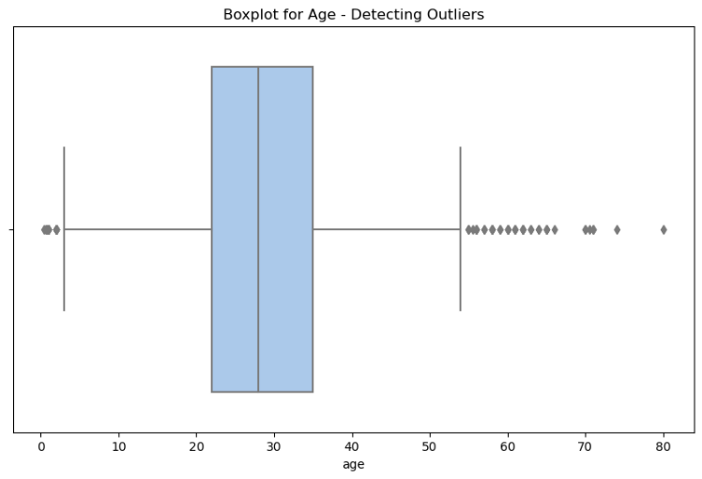***Dataset Preprocesing and Visualization:***

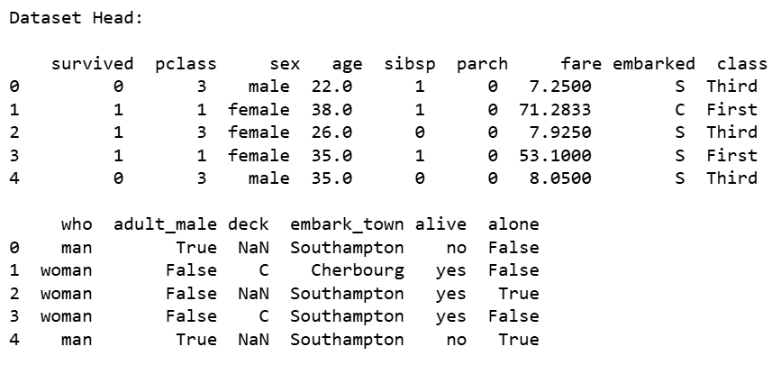

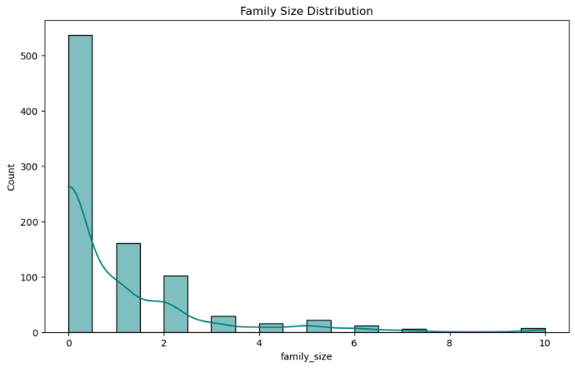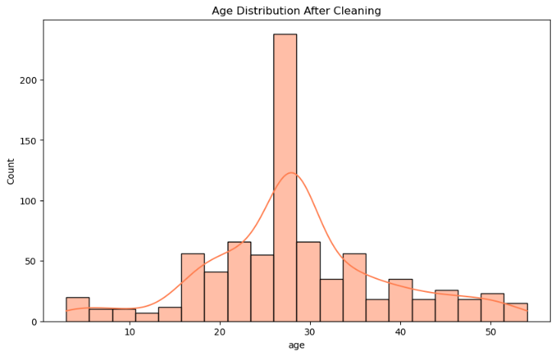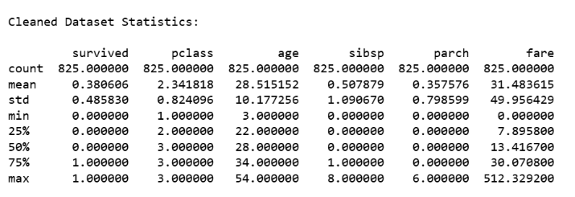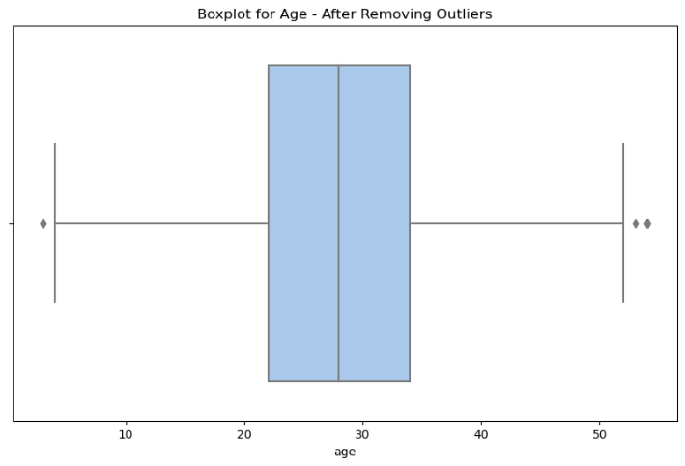

***Fig 6: Family Size Distribution***

***Fig 5: Age Distribution after Cleaning***

***Fig 4: Descriptive Statistics after Preprocessing***

***Fig 3: Box Plot after Removing Outliers***

***Fig 1: Dataset Printing***

***Fig 2: Box Plot for Detecting Outliers***